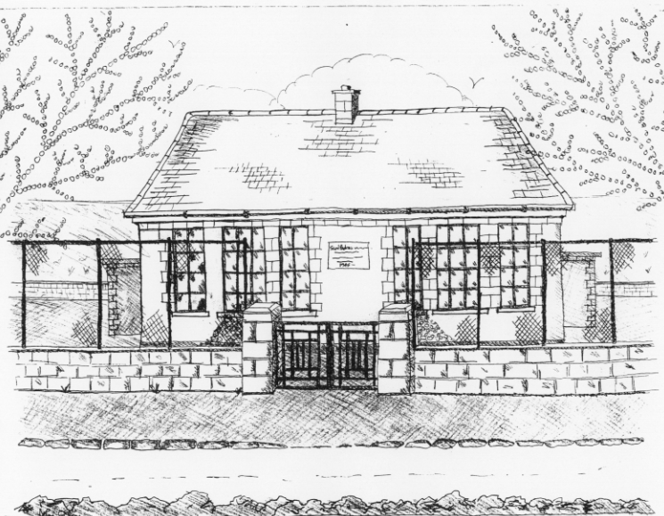 St. Patrick’s NS Booklist 2017-18

3rd Class

Books to be Purchased by Parents

Books to be Bought

Spellbound C. (Folens)
Am Don Léamh 3 (Folens)
Sin E 3 (Edco)
Master Your Maths 3. (C.J Fallon)
Planet Maths 3 (Folens)
All Write Now 3rd class (Folens)
D Tin Whistle

Copies & Ancillary materials
2 Sum Copies 88 Page 7mm
8 x 88page page writing copies.
1 x 40 page copy
1 x handwriting copy B4 lined
Homework Journal (Fallons)
1 x 10pg Display Folder (Tin whistle music)
1 x 20pg Display Folders ( Self Assessment Learning Folder)
1 x 40pg Display Folder (Finished Work)
1 x 100 page small hardback notebook (vocabulary)

School Costs

Art & Crafts Fees  Photocopying Fees  Book Rental Scheme Fee (please see overleaf for books included) | €10  €10  €15
TOTAL: | €35

Costs can be paid in full or in instalments as suits.
Please enclose in an envelope labelled with your child’s name and class and amount

- Please put your child’s name on all books, coats, hats cardigans/jumpers and other belongings

School Book Rental Scheme 3rd Class (€15 as above)

 | Purchasing Price
SESE  History Quest  Geography Quest  Windows of the World Geography  Windows of the World History  Atlas | €10.50  €11.00  €8.95  €8.95  €14.00
English  Class Novels (3 – 4)  Trolls, Squirrels & Dragons (Carroll Ed. Ltd)  Trolls, Squirrels & Dragons Skills Book (Carroll Ed. Ltd) | €7.99 each  €13.75  €8.95
Religion  Grow in Love 3rd Class | €12.99

