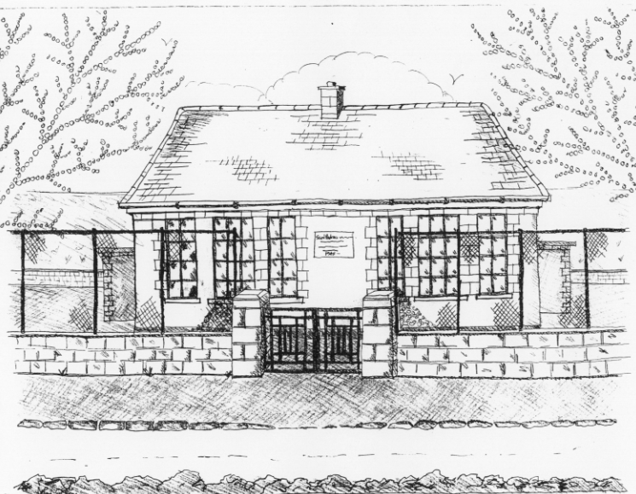 St. Patrick’s NS Booklist 2017-18

2nd Class

Books to be Purchased by Parents

Books to be Bought
The Green Genie Combined Reading and Activity (Folens)
Sin E 2 (Edco)
Master Your Maths 2. (CJ Fallon)
Planet Maths 2 (Folens)
Grow In Love 2nd Class (Veritas)
All Write Now 2nd class (Folens)

Copies & Ancillary materials
2 Sum Copies 40 Page 10mm
8 x 40page writing copies
Homework Journal (Fallons)
*2 x 20pg Display Folders ( Self Assessment Learning Folder) *Keep from 1st class
1 x 40pg Display Folder (Finished Work)

Each child will need a pencil case with the following items.
2 pencils, 1 rubber, 1 x 12 pack twistable colours, 1 large Pritt Stick Glue.

School Costs

Art & Crafts Fees  Photocopying Fees  Book Rental Scheme Fee (please see below for books included) | €10  €10  €10
TOTAL: | €30

Costs can be paid in full or in instalments as suits.
Please enclose in an envelope labelled with your child’s name and class and amount

School Book Rental Scheme 2nd Class (€10 as above)

 | Purchasing Price
SESE  History Quest 2  Geography Quest 2 | €8.60  €8.60
English  Class Novels (1 – 2)  Ancillary Readers (approx. 20) | €9.99 each  €7.99 each

