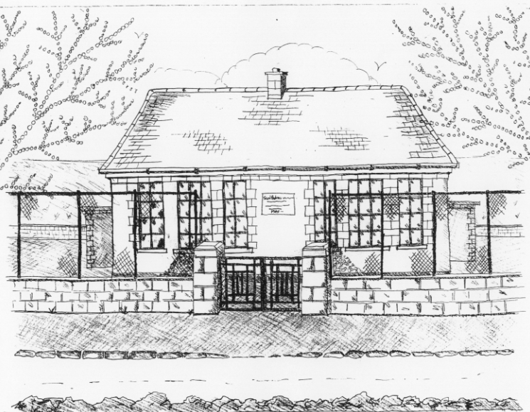
St. Patrick’s National School,
Glencullen,
Dublin 18.
Tel (01) 2954255
Email secretary@glencullenschool.ie
Website: www.glencullenschool.ie
Roll Number: 17507F

JUNE NEWS 2016 & UPCOMING EVENTS

School Closure
To facilitate the Bank Holiday weekend our school will close on Thursday 2nd June at 3pm and reopen Tuesday 7th June at 9.20am.
Irish Aid Awards
Congratulations to 5th class who were one of three winners of the regional finals of the Irish Aid Our World Awards! They are now through to the National Finals of 12 schools in Dublin Castle on Tuesday 14th June. We wish them the very best of luck and congratulate them on getting this far in the competition!!

Discover Primary Science
We have once again been awarded the DPS Award of Excellence in Science and Maths. Congratulations to all the boys and girls. Sincere thanks to Ms. Quigley for coordinating the activities in our school.

6th class Graduation
Our 6th class pupils will graduate from St. Patrick’s NS with a special ceremony on Monday 27th June. This will begin with a graduation mass in the hall at 7.30pm followed by a special celebration. All 6th class students, their parents and family members are warmly invited to this night.

School Tours
We have a number of school tours taking place in June. Junior Infants are heading up to the Pine Forest Art Centre on the 1st June. On the same date 5th class go on their tour to Larchill Adventure Centre. 1st class will visit Lullymore Farm on June 13th. And finally 6th class will go to Glasnevin Cemetry, St. Patrick’s Cathedral and the Viking Splash on the 29th. Thank you to all the fundraising efforts which cover the costs of all buses.

Tidy Schools Award
Congratulations everyone on our recent Award of Distinction in the Tidy Schools programme. Sincere thank you to our litter pickers, Ms. Skelly, our Gardening Parents Committee, Denis Mulvey, and Betty O’ Connor for all the work they continue to do maintaining our beautiful grounds.

Cumann na mBunscol
Despite a valiant effort at this year’s semi-final, our Cumann na mBunscol team were unfortunate not to make it to the Croke Park final this year. We are very proud of each team member and how they never gave up until the whistle blew. Sincere thanks to our coaches Peter Keane, Jason Sinclair & Mr. Coughlan for their continued commitment to our team.

Garda Safety Course
Over the past year 5th class have engaged in a number of workshops with Garda Pat Cullen & Garda Mandy Lowe regarding personal safety & local citizenship. This course will conclude next month and all children will be presented with a certificate. Sincere thanks to both Gardaí in guiding our students.

Senior Play
Our 5th & 6th class will perform ‘Charlie & the Chocolate Factory’ on Tuesday 28th June. Parents & family are most welcome to come to this performance at 1.30pm.

Junior Infant Open Day
We welcome our new Junior Infants and their parents to our school for a visit on Thursday 16th June. Our current Junior Infants will go home at 1.30pm to facilitate this.

Uniform Swap
Thank you to Deirdre Mc Cabe who is organising a Uniform Swap on Monday 27th June between 2-3pm in the school hall. Please keep any uniform items that are in good condition & clean that could be donated to this swap.

Active Schools & Wellbeing Week
Between the 20th -25th June we will hold an Active Schools and Wellbeing Week here at St. Patrick’s The goal will be for pupils and parents alike to focus on health, nutrition, physical exercise and mental health throughout the week. We have lots of activities for the children including GAA, Athletics, Netball, Self Defence, Meditation, Yoga & Nutrition classes as well as a week-long Olympic team tournament for every child in the school. This will all culminate in Sports day on the last day. We hope to also have a few activities for parents as well as Active homework for all!!

Sports Day
This year we will have our school Sports day on Friday 24th June in the Stars of Erin GAA field, weather permitting. We will leave the school at 12.00am to walk up to the field. Each child will walk with their class and class teacher but parents are welcome to walk along with us. This year our Sports Day focuses on the final event of our St. Patrick’s Olympics. There will be a team relay for every child in the school in both the Junior & senior tournament. The individual races will have already taken place in school during the Active Schools Week Olympic tournament. Our PA have organised a Zumba class and Yoga class on the pitch along with Smoothie tasting. We hope to offer complimentary tea & coffee to parents. Our PA will be looking for parent volunteers to help out. Families are welcome to bring a picnic but remember to bring your rubbish home. Parents are asked to strictly supervise their children especially the very young and keep them away from dangerous areas. At the end of the day approx. 2pm, parents can bring their child home from the field but remember to check out with the class teacher. We look forward to sunshine and lots of fun!!

First Aid Course for 6th class
Thanks to fundraising this year, we are in a position to provide a first aid course for 6th class before they leave us this year. This will take place in school hours and will be facilitated by First Aid trainer Pat Reid. We hope this valuable skill will stand to our young people in the future.

School Reports
Please be aware that every child will bring home their school report on Friday 17th June. All school reports must include standardised test results but as educators, we urge you to read the whole of the report and not focus solely on the results. We believe your child is so much more than a number on a Maths or Reading test. Of course if a parent is concerned about any test result, please speak with your child’s teacher.

Thank you Parent Committees
Many thanks to all our many parent volunteers this year who actively assisted not only on the Parent’s Association but also the IT committee and the Gardening committee. A special thank you to each of our class reps. Thank you to those who assisted with the Sacraments including the 1st class Reception Committee. Thanks to all those individual volunteers who assisted with various events throughout the year including our coaches for Cumann na mBunscol, Choir, Netball, School plays, Science days, Art days, school tours and much more. Thank you to those who made copious cups of tea at various receptions throughout the year. Thank you to everyone who helped to organise and assist at our many fundraising events, especially this year’s spectacular Strictly St. Patrick’s. Your help and support is invaluable in enriching our children’s education and is always very much appreciated.

Thank you Staff
A sincere thanks to each of our staff members who continuously go above and beyond for the pupils in our school. For the many hours of their personal time that they give up to facilitate swimming, football & hurling matches, sacraments, school tours, award ceremonies, fundraising events and much more, I sincerely thank them. The commitment from both our staff & parent body is what makes our school so special!
Thank you Sean & Clara Flynn
Thank you to pupils Sean (1st class) & Clara (Sen. Inf.) who ran the Great Limerick Run. In doing so, €5 was donated to their school for each child. Well done on taking part in the race and raising funds for our school.

Golden Book
As you know we have a special initiative to recognise pupils who demonstrate exceptional skills, talents, academic achievement, acts of selflessness, generosity & kindness in our school. These children are nominated by teachers or peers and are honoured with being included in our Golden Book.

A huge congratulations to all children who were nominated into the Golden Book this year and forthcoming in June. Keep reaching for success and being the very best you can be!

Summer Holidays
School will close for the Summer on Thursday 30th at 12.30pm. School will reopen on Wednesday 31st August at 9.20am. A full list of closures for 2016-17 will accompany your booklist during June.

Wishing you all a very safe & happy Summer holidays!

