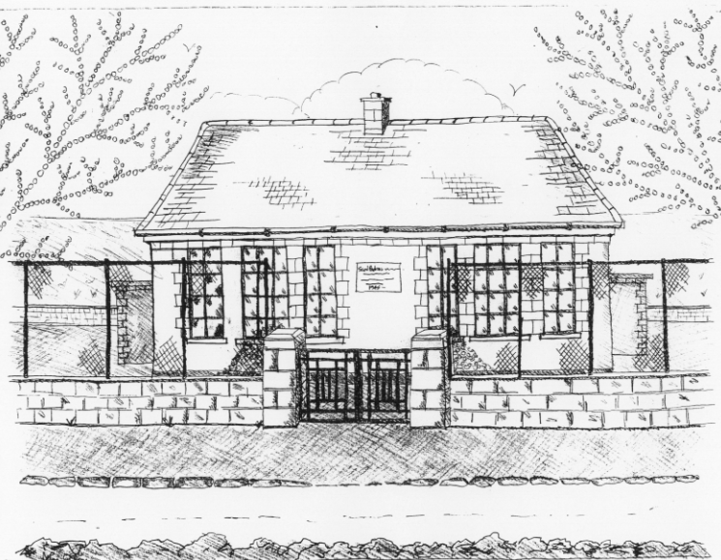
St. Patrick’s National School
Glencullen,
Dublin 18.
Tel (01) 2954255
Email secretary@glencullenschool.ie
Roll Number: 17507F
www.glencullenschool.ie

APRIL NEWS & UPCOMING EVENTS

Tidy Schools Competition & National Spring Clean
This month we are taking part in the DLR Tidy Schools Competition and the National Spring Clean. Already the children and staff are making an extra effort to keep our school clean and tidy, with a special thank you to Betty for her beautiful window boxes to the front of the school. We would love to see our Parents Gardening committee up and running again. Already parent Conor Byrne has replaced some of the rotten benches in the garden. If available please drop your name into the office. Together we can keep our school a beautiful, enjoyable place to learn & play in.

Cumann na mBunscol Hurling League
Good luck to our school hurling team who begin the league this Thursday at 3pm at the Stars of Erin pitch against Scoil Padraig Naofa, Ringsend. Our next match against Scoil Colm takes place at home Thursday 14th at 3pm. This will be followed by their third match away on Thursday 21st 3pm against Scoil Dominic. All supporters welcome! Many thanks to our coaches Peter Keane and Jason Sinclair. Thanks to Mr. Coughlan and Ms. Doyle for assisting Ms. Byrne with the supervision.

Gymnastics
Gymnastics will begin Monday 4th April in school with Olympian Gymnastics for every class. Classes will take place for 6 weeks and are free of charge thanks to the PA fundraising. All children can wear their tracksuit on Mondays.

Swimming reminder
A new swimming term will begin Thursday 7th April in Meadowbrook pool for Junior Infants and 1st classes. Pupils have the option to return by bus or to be collected by a parent. However we kindly request that parents choose an option and remain with that option for the term of swimming. We understand that in an emergency it may be necessary to change arrangements. But it is not acceptable to change arrangements weekly without informing the school or the child. Please choose an option and remain with that decision for the duration of the term.

Should your child have a medical condition that prevents them from swimming, please write to the Board of Management requesting an exemption.

Emma Redden, Parents Rep for Junior Infants, will be happy to speak to any new parents regarding swimming.

And please remember there is no supervision for siblings at 3pm so if you need to make arrangements with other parents or family members for collection, please do so.

Bags to School Collection
All bags of donated clothing will be accepted on Wednesday 13th between 9.00-9.30 in the Rachel Murphy Hall. Bags cannot be collected after this time as they will be collected by the company Bags 2 School that day. Under no circumstances are bags to be left on school grounds at any time. Many thanks to Shona Leonard for organising this.

Visual Screening for Senior Infants
Visual Screening for Senior Infants will be completed by the HSE in our school on Tuesday 26th April.

First Penance
The Sacrament of Penance for the pupils of 2nd Class will take place on Tuesday 12th April at 7.30pm in St. Patrick’s Church, Glencullen.

Transition from Primary to Post Primary School Education Talk
A talk will take place on Monday April 11th at 8pm in Kilternan Church of Ireland National School exploring the issues of transitioning from Primary to Second level. A flyer went out to all children in 4th, 5th & 6th class before Easter. If anyone would like to attend, please give your name to Betty in the Office, as the committee need to get an idea of numbers attending.

One Good Idea Competition
Good luck to 6th class who are through to the semi-finals of the One Good Idea Competition. One Good Idea is a competition focused on making everyone more aware of the amount of energy we are using.

“Our topic is Greener Fashion and for this we sent our surveys to families in our school about how to look after our clothes. We have organised a clothes swap (thank you to parent Lisa Pennington for your help with this!) and a green fashion show.
We are presenting power points to all the classes on how to look after your clothes and save energy. We have looked at the journey of our school jumper. We have made posters and have made up a dance and song. We hope to get further on in this contest. Our slogan is “Being Green is Our Passion and We Show it in our Fashion!”
By Kate Collins, Oisín Byrne & Emma Mooney 6th class

School Uniform
For parents convenience we have placed a timetable of Uniform & Tracksuit days on the windows for the month of April. We will try to keep this updated each month

Golden Book
As you know we have a special initiative to recognise pupils who demonstrate exceptional skills, talents, academic achievement, acts of selflessness, generosity & kindness in our school. These children are nominated by teachers or peers and are honoured with being included in our Golden Book.

This month’s honourees are;

Gracie Howlin Jun. Inf.
Adam Greenlee 1st class
Riona Moulton 5th class

